

Networks and Internet

Research Assignment



Kamohelo Leokaoke

Zaio

08 May 2020

Introduction

In this assignment I will be exploring a few key concepts in regards to and understanding the principles of the Internet the world wide web and how it operate .

We will be working with three possible problems or rather challenges that may occur . We will look at helping a student who is doing training at Zaio , in understanding the principles of the Internet and the world wide web .Another challenge we will address is explaining how the world-wide-web incorporates various internet applications to our new network engineer . Lastly , we will have a look at a few pictures of three web pages on the internet as we look at the physical context of the web pages.

I will be addressing three key problems or challenges in understanding the principles of the Internet and the world wide web such as the origin and history of the internet as well as that of the world wide web . I am also aim at going a little into depth in regards to the physical context of web pages and how the word-wide-web can be applied in an intranet and extranet , whilst explaining a bit about the latest internet application and web-based email . I will also visit any three web pages on the internet and talk about the physical context of the web pages.

After reading this one will hopefully have more of an understating in how Internet and the world wide web and how it operates as well as understanding the principles of the Internet the world wide web . Simultaneously , one would also have more of an understanding in regards the possible challenges in the working environment and general communication between students and colleagues .

In conclusion , we will have a visual representation of what could possibly be on the internet .

Contents

1. The principles of the internet and world-wide-web .

* Origins and history of internet .
* Major applications of the internet .
* Major internet applications .
* History and development of world-wide-web .

1. How the world wide-web incorporates the various internet applications .

* Physical context of web pages .
* How the word-wide-web can be applied in an intranet , extranet and the latest internet application including web-based email and instant messaging .

1. Visual representations of three web page on the internet .

* Screenshots of the visited web pages .

1. The principles of the internet and world-wide-web

* Origins and history of internet .

The origin and history of internet date backs to the 1960s, when developers saw great potential in computers with regard to sharing information on scientific and military research. In 1962, J.C.R Licklider proposed a global network of computers . A network is a group of two or more computer systems linked together.

Later that year he moved on to Defense Advanced Research Projects to actually develop it. After sometime, the theory of packet switching was developed by Leonard Kleinrock, which formed the basis of internet connections . The Internet is the largest computer network in the world, connecting millions of computers.

In the year 1965, Lawrence Roberts of MIT connected a Massachusetts computer with a

California computer over dial-up telephone lines. This established the viability of wide area

networking and even proved that the telephone line circuit switching was inadequate. Thus,

Kleinrock packet switching theory was confirmed.

In 1966, Roberts shifted to DARPA, to develop his plan for ARPANET. The dream was realized in 1969, when ARPANET was brought online . This took place as per a contract renamed Advanced Research Projects Agency, which connected four major computers at universities in the south-western US. With time, more and more members joined the contract. Thus, internet was initially known as ARPANET.

The internet was primarily used by computer experts, engineers, scientists and librarians. As there were no personal computers in that age, the users were few, who had to learn a complex system of operation . In the 1970s, internet matured further, with the invention of TCP/IP architecture first proposed by Bob Kahn at BBN and further developed by Kahn and Vintcent Cerf at Stanford.

In 1978, UNIX to UNIX Copy Protocol (UUCP) was invented at Bell Labs, which formed the basis of Usenet. This was used by newsgroups for discussion on topics, thereby providing a means of exchanging information throughout the world . It was later adopted by the Defence Department in 1980 and universally, in 1983.

BITNET (Because It Time Network) arrived, which when connected with the internet allowed exchange of e-mail, especially e-mail discussion lists . In the year 1986, the National Science Foundation funded NSFNet, as a cross country 56 Kbps backbone for the Internet, and even laid down rules for its non-commercial government and research uses. As the commands for e-mail, FTP and telnet were standardized, internet usage became quite easier for non-technical people.

However, with more and more usage of the net, Internet index was created in 1989 . The present day internet was actually designed to device a communication network that would be operational even if a few sites were destroyed by nuclear attack. This would mean that if direct route was unavailable, routers would direct traffic around the network, via alternative routes.

* Major applications of the internet .

1. **Electronic mail** - At least 85% of the people that use the internet send and receive e-mail. On average 20 million e-mail messages cross the Internet every week.
2. **Research** - Gathering of various information .
3. **Downloading files** - Pictures ,Videos,applications ect.
4. **Discussion groups** - These include public groups, such as those on Usenet, and the private mailing lists that lists server manages.
5. **Interactive games** – Like tetras or solitaire .
6. **Education and self-improvement** - On-line courses and workshops .
7. **Friendship and dating** – like facebook and dating sites .
8. **Electronic newspapers and magazines** - This includes late-breaking news, weather, and sports.
9. **Job-hunting** - Classified ads are in abundance, but most are for technical positions.
10. **Shopping** - It appears that “cybermalls” are more for curious than serious shoppers. Like Takealot or amazon .

* Major internet applications .

Search Engines are now part of our daily life, whether we are looking for best Steak House in town or where is the nearest coffee shop open before 7am is . Internet applications can be described as Search Engines and people are now becoming more dependent on search engines to get the answer for their everyday queries.

[**Google**](http://www.google.com/) - Almost 70 percent of the Search Engine market has been acquired by Google . The software developers are always evolving and looking to improve the search engine algorithm to provide best results to the end-user. As of 2015 YouTube is now more popular than Google (on desktop computers).

[**Bing**](http://bing.com/) - Bing is the default search engine in Microsoft’s web browser. Bing is Microsoft’s answer to Google and it was launched in 2009 . Microsoft’s search engine provides different services including image, web and video search along with maps . Bing introduced Places which is the equivalent of Google’s , Google My Business , this is a great platform for business to submit their details to optimise their search results .

[**Yahoo**](http://yahoo.co.uk/)- Yahoo & Bing compete more with each other than with Google. As a leader of free email provider, this is declining significantly though with their recent acknowledgement that User Details & Passwords where hacked last year.

[**Baidu**](http://baidu.com/) - Baidu is the most used search engine in China and was founded in Jan, 2000 by Chinese Entrepreneur, Eric Xu. . This web search is made to deliver results for website, audio files and images. It provides some other services including maps, news, cloud storage and much more .

[**AOL**](http://aol.co.uk/) - Aol.com is also a top search engine . AOL is a global mass media company which is based in New York. . Verizon Communication bought AOL for $4.4 billion. It was started back in 1983 as Control Video Corporation. It was named America Online in 1991 and in 2009 as AOL Inc. The company also provides advertising services as AOL Advertising, AOL mail and AOL Platform.

[**Ask.com**](http://ask.com/) - Ask.com, previously known as Ask Jeeves was founded in 1995 . . It is a question & answer community where you can get the answers for your question and it integrates a large amount of archive data to answer your question. The dependency on archived and active user contributions results in the search not being as current as those you get in Google, Bing and Yahoo.

[**Excite**](http://www.excite.com/) - Excite is an online service portal that provides internet services like email, search engine, news, instant messaging and weather updates .

[**DuckDuckGo**](https://www.duckduckgo.com/) - DuckDuckGo is a popular search engine known for protecting the privacy of the users. It was founded by Gabriel Weinberg in California back in 2008 and its revenue comes from Yahoo-Bing search alliance network and Affiliates.

[**Wolfram Alpha**](https://www.wolframalpha.com/) - Wolfram Alpha is a computational knowledge search engine which does not give list of documents or web pages as search results. Launched in 2009, their mission statement is to make all systematic knowledge computable and broadly accessible . Results are based on facts & data about that query.

[**Chacha.com**](http://www.chacha.com/) - Chacha.com was founded in 2006 and it is a human-guided search engine . You can ask anything in its search box and you will be answered in real-time. It also provides mobile search and marketing services. You can also install its mobile applications for Android or Apple .

* History and development of world-wide-web .

The introduction of the World Wide Web took place in 1991, it was developed by Tim Berners-Lee at CERN, the European Organisation for Nuclear Research, in Geneva. This was a menu-based system, which was originally envisioned as an internal document-management system, now organizes Internet resources throughout the world into a series of hypertext-linked menu pages which was based on hypertext. The system included inserting links in text, to link to other text, which you have been using every time you selected a text link while reading these pages.

In 1993, the protocol got a big boost from the graphical browser ‘Mosaic’ by Marc Andreessen and his team, at the National Centre for Supercomputing Applications (NCSA). Andreessen was also the mastermind behind Netscape Corp. , which produced the most successful graphical type of browser and server until Microsoft declared war and developed its Microsoft Internet Explorer.

Since Internet was initially funded by the government, its usage was limited to research, education and government application, strictly prohibiting commercial use . This continued till early 1990s , when independent commercial networks began to grow. As a result, it became easy to route traffic across the country from one commercial site to another, without passing through government funded NSFNet Internet backbone.

The first national commercial online service to offer Internet access to its subscribers was Delphi. In 1992, it offered an email connection and full Internet service . In 1995, the limitations on commercial use disappeared, as National Science Foundation ended its sponsorship of the Internet backbone. After this, the commercial market saw a major shift, with Bill Gates Microsoft full scale entry into the browser, server, and Internet Service .

In 1998, Windows 98 was launched, with the Microsoft browser well integrated into the desktop. Since then, the company as well as internet hasn’t looked back.

1. How the world wide-web incorporates the various internet applications .

* There are two types of website content: text and media : Text and Media

Text - Text is the written content on the page. The most effective textual content is written with a global audience in mind, since websites can be read by viewers anywhere in the world. Good textual content follows the guidelines for online reading, such as breaking up the text with headers, bullets, and brief paragraphs. It also includes helpful links to internal and external sources so readers can take explore the information presented even more .

These are examples of text on a web page :

* Your hours of operation or contact information
* Articles that help customers and potential customers
* A useful blog that gives readers a reason to visit again
* Press releases that announce new products, services, and initiatives
* Information about upcoming events

Media - Includes animation, images, sound, and video and is any content that isn't text. The key to using any of them successfully is to not interfer with the site's main messages with visual or technical distractions.

These are examples of media/multimedia on a web page :

* **Animations** - It's important to ensure the "wow factor" of the animation adds to, rather than distracts from, the primary message of the page.
* **Images** - You should optimize website images so they load and download quickly, so the artwork contributes to frictionless content viewing.
* **Sound** - keep in mind that not everyone appreciates website sound, especially if you have it turn on automatically with no way to turn it off.
* **Video** - incredibly popular on websites. But adding a video that works reliably across different browsers can be challenging. One of the easiest ways to avoid a video that viewers can't get to work , is upload the video to a service like [YouTube](https://www.lifewire.com/youtube-101-3481847) or Vimeo and then use the "embed" code from that site within your web page.
* How the word-wide-web can be applied in an intranet , extranet and the latest internet application including web-based email and instant messaging .

The Internet is accessed using the TCP/IP. The Hypertext Transfer Protocol (HTTP) is an application-level protocol that is used to transfer the collection of online documents known as the World Wide Web (WWW). This application service and combines the use of client software (browser) that can request information from web servers. Web-based applications can deliver static and dynamic content in the form of text, graphics, sound, and data .

They can be used as an interface to corporate applications. Delivery of information via the Web can include the use of either client-side (servlets or applets) or server-side (common gateway interface scripts [CGI]) applications. The ease of implementation and use of the Web enables a variety of content-rich applications.

An intranet uses the same basic principles of the Internet but is designed for internal users. Intranets are web based and can contain internal calendaring, web email, and information designed specifically for the authorized users of the intranet. Extranets are web based but serve a combination of users. Extranets are commonly used as a place for partners (organization and external partners) to exchange information. A simple example of an extranet is one in which a supplier provides access to its partners to place orders, view inventory, and place support requests. The extranet usually sits outside the corporate border router and might be a screened host or might be maintained on a screened subnet.

With the wide use of web technologies, it is important to develop policies and procedures regarding proper use of the Internet, the intranet, and extranets. The ease of access via the Web opens the door to the organization’s network and could allow the download of virus-laden or malicious software. Users in the organization need to be aware of the risks associated with downloading potentially dangerous applets, servlets, and programs. The IT organization should monitor Internet access to ensure that corporate assets (bandwidth, servers, and workstations) are being used in a productive manner.

This may be the type of email that most users are familiar with. Many free email providers host their servers as web-based email. This allows users to log into the email server through the use of an Internet browser to send and receive their mail. It is useful for people on the go since they can check their email anywhere they have access to the Internet.

Instant messaging technology is a type of online chat that offers real-time text transmission over the Internet. A LAN messenger operates in a similar way over a local area network. Short messages are typically transmitted between two parties, when each user chooses to complete a thought and select "send" Voice over Internet Protocol, also called IP telephony, is a methodology and group of technologies for the delivery of voice communications and multimedia sessions over Internet Protocol networks.

1. Visual representations of three web page on the internet .

* Screenshots of the visited web pages .

Creative web page - <https://velvetspectrum.com/>

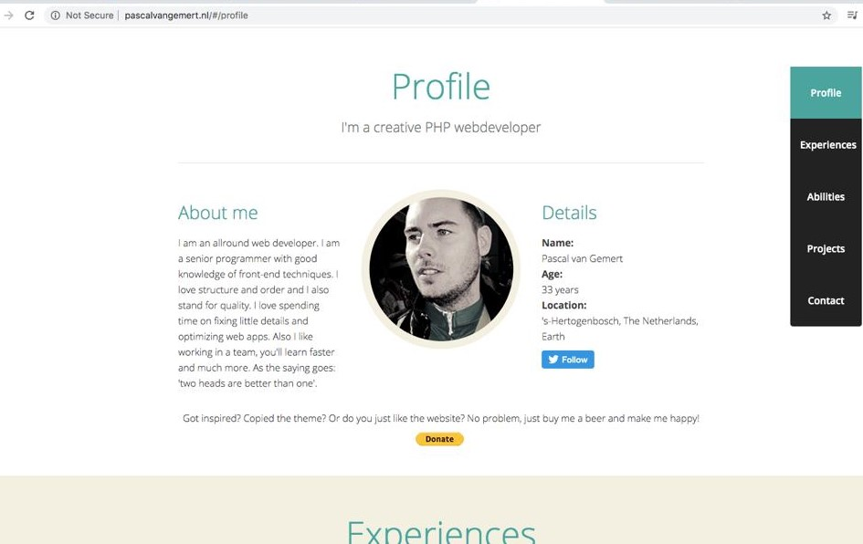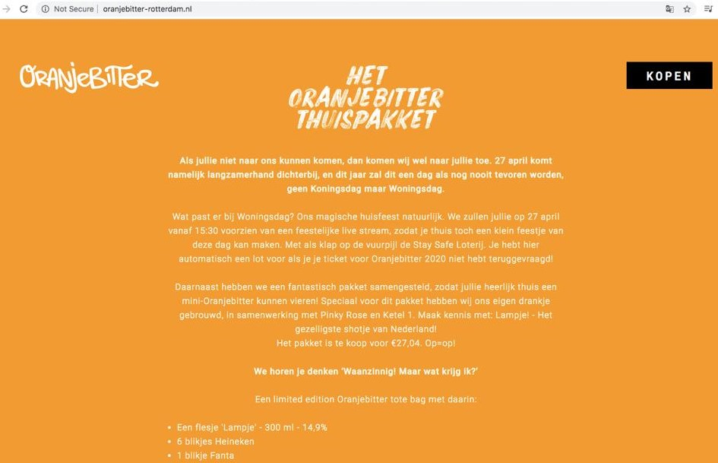

Uses both text and multimedia but mainly focused on text .

*Personal web pages -* [*http://www.pascalvangemert.nl/*](http://www.pascalvangemert.nl/)

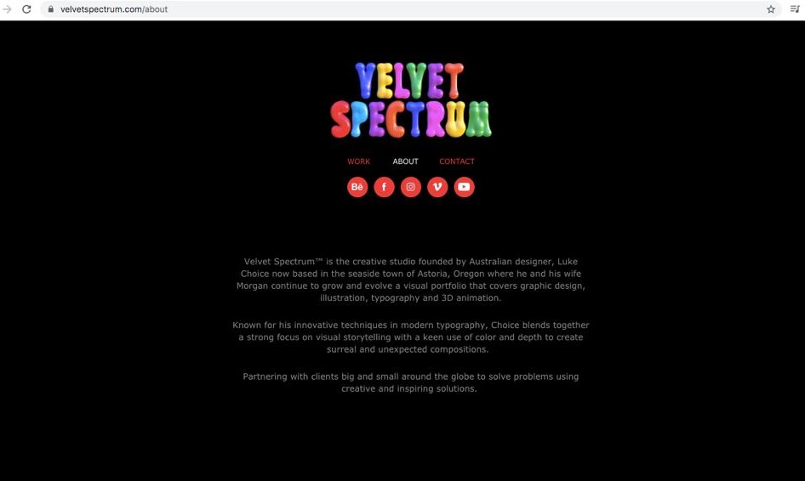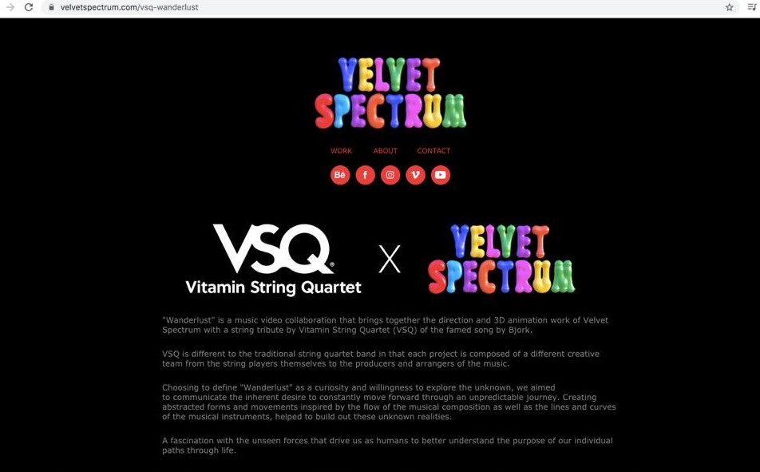

*Uses both text and multimedia but mainly focused on multimedia .*

*Informational web pages -* [*https://airbnb.com/*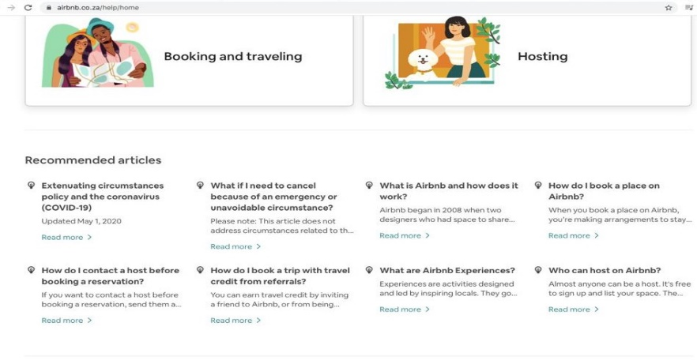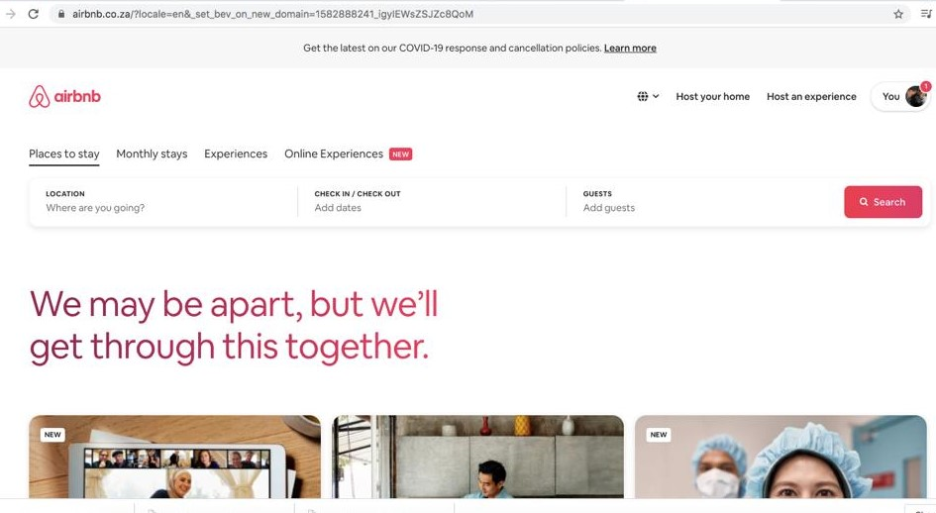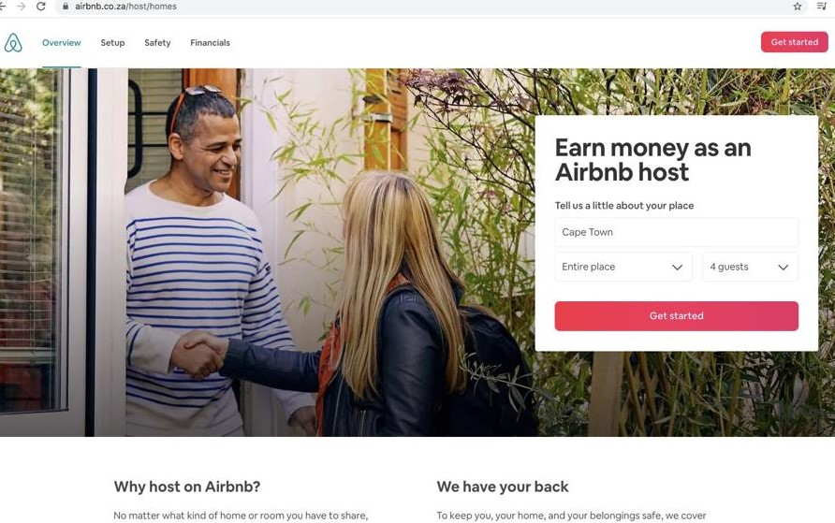](https://airbnb.com/###)

Uses both text and multimedia with a fair balance between the different mediums .